Lappeenrannan teknillinen yliopisto

School of Business and Management

Software Development Skills

Sonika

LEARNING DIARY, FULL STACK DEVELOPMENT MODULE

**LEARNING DIARY**

I checked the general information and understood the main focus of the course, which is to find my passion as a software developer and create a unique project to represent my skills. I chose frontend module because it was the most interesting project offered. I’ve also tried to set up my environment, but I could not decide which code editor I would like to use. I learned to set up a git repository and did my first commit, everything went smoothly after I clicked the banner to watch intro of the topic. So, I have today learned about the following topic.

**Date- 6 july2024**

Today I have learned about the GitHub

**Git**

it is the distributed the version control system

which is used to track the files, folders, code and projects of the employee, person etc.

which is used by the different person and it is also help to collaborate the files.

There are different kind of the features which are as follow:

1. Version control- it is the distributed version control system, in which we can do the changes in the files, according the period of time and this can be change by anyone who has the knowledge of it.
2. Distributed system – it can be operated in a local way or it is the fast operated system and it also does not need the network connection.
3. Collaboration – it can be used by anyone and also help to collaborate with the other employees in the organisation. They can review to each other’s and also help to merging the things in it.
4. Flexibility- it is one of the highly way of flexibility for any project and collaboration and many other things in a professional way.



Source- <https://www.bing.com/images/search?view=detailV2&ccid=lhH2Aodx&id=3B9CFA0ECE182E962BE854885217E0B5B5966CD0&thid=OIP.lhH2AodxozEbYxSDLz8BUAHaEK&mediaurl=https%3A%2F%2Flogospng.org%2Fwp>.

Date -7 /7/2024

I learned about following topic, which help me to understand the topic and help me to know more about the information of this topic and it seems interesting to me to know more about this topic.

Git common terminology

1. Repository (repo) – it contains all types of the files, in which includes the history of the project also.
2. Commit – it is the that in which we can commit the changes in the files and know about how to do the changes in the files.
3. Merge – it is that terminology where we can easily find the two things to merge the files and combines the files.
4. Clone – this the copy of the same original files.

Commands of git

There are as follow-

1. Git init- it is the process to start a repository
2. Git clone – this is the that command which is used for to copy the repository.
3. Git add – it is the stage file
4. Git push – its is for the upload changes
5. Git checkouts – it is for switch branch.
6. Git merge – for combine branches

Date -8 /7/2024

I learned about following topic, which help me to understand the topic and help me to know more about the information of this topic and it seems interesting to me to know more about this topic.

**Mongo Db**

It is the one type of the database which helps to store information from the traditional database.

It is not put the data in the table form although it is store the data in the bunch of notes as its example.

Date -9 /7/2024

I learned about following topic, which help me to understand the topic and help me to know more about the information of this topic and it seems interesting to me to know more about this topic.

Benefits of mongo db

1. Flexibility – it stores the data in a flexible way for example – json – like documents.
2. Speed – it is the fast way to store the data .
3. It is the high availability.
4. It has a multi work load capacity.

Date -10/7/2024

I learned about following topic, which help me to understand the topic and help me to know more about the information of this topic and it seems interesting to me to know more about this topic.

Commands of the mongo db

1. Create a database – use <database_name>
2. Show all database- show dbs
3. Create a collection – db.createcollection (<collection_name>
4. Insert a document- db.<collection_name>.insert({key:value})
5. Delete documents- db.<collection_name>.remove({key:’value’})
6. Drop a collection – ‘db.<collection_name>.drop()’.

Express.js

It is that framework which is the lightweight to build the web applications in the node.js .

React.js

It is the frontend library which is developed by the Facebook for to build the user interfaces.

It is mostly preferable the single pages applications.

Date -11/7/2024

I learned about following topic, which help me to understand the topic and help me to know more about the information of this topic and it seems interesting to me to know more about this topic.

Node.js

It is the environment of the run time which help us to allow to run the JavaScript on the server side.

|  |  |
| --- | --- |
| react | Node.js |
| 1. It is the JavaScript library | It is the JavaScript runtime environment. |
| 1. It is mainly used for the frontend Ui development | 2.It is mainly used for the server-side programming |
| 1. It run in the browser | It run in the server |
| 1. It is the part of the web development stacks | It is used for the server and the network applications |

Date -12/7/2024

I learned about following topic, which help me to understand the topic and help me to know more about the information of this topic and it seems interesting to me to know more about this topic.

Commands of the react.js

1. Components creation and the lifecycle methods

function MyComponent() {

return <div>Hello, World!</div>;

}

1. Class components

class MyComponent extends React.Component {

render() {

return <div>Hello, World!</div>;

}

}

1. React hooks commands –

import React, { useState } from 'react';

function Counter() {

const [count, setCount] = useState(0);

return (

<div>

<p>You clicked {count} times</p>

<button onClick={() => setCount(count + 1)}>Click me</button>

</div>

);

}

Date -13/7/2024

I learned about following topic, which help me to understand the topic and help me to know more about the information of this topic and it seems interesting to me to know more about this topic.

Commands

1. Use effects-

import React, { useState, useEffect } from 'react';

function Timer() {

const [count, setCount] = useState(0);

useEffect(() => {

const timer = setInterval(() => setCount(count + 1), 1000);

return () => clearInterval(timer); // Cleanup on unmount

}, [count]);

return <p>{count} seconds have passed.</p>;

}

1. Use context-

import React, { useContext } from 'react';

const MyContext = React.createContext();

function MyComponent() {

const value = useContext(MyContext);

return <div>{value}</div>;

}

Date -14/7/2024

I learned about following topic, which help me to understand the topic and help me to know more about the information of this topic and it seems interesting to me to know more about this topic.

Commands

1. Use reducer-

import React, { useReducer } from 'react';

function reducer(state, action) {

switch (action.type) {

case 'increment':

return { count: state.count + 1 };

case 'decrement':

return { count: state.count - 1 };

default:

throw new Error();

}

}

function Counter() {

const [state, dispatch] = useReducer(reducer, { count: 0 });

return (

<div>

<p>{state.count}</p>

<button onClick={() => dispatch({ type: 'increment' })}>+</button>

<button onClick={() => dispatch({ type: 'decrement' })}>-</button>

</div>

);

}

Date -15/7/2024

I learned about following topic, which help me to understand the topic and help me to know more about the information of this topic and it seems interesting to me to know more about this topic.

1. React methods –
2. React.createelement()

const element = React.createElement('div', { className: 'greeting' }, 'Hello, World!');

1. Reactdom.render()-

import ReactDOM from 'react-dom';

ReactDOM.render(<App />, document.getElementById('root'));

c)react.cloneelement()-

const newElement = React.cloneElement(element, { className: 'new-class' });

Date -17/7/2024 and 18/7/2024

I learned about following topic, which help me to understand the topic and help me to know more about the information of this topic and it seems interesting to me to know more about this topic.

8.jsx syntax-

A) basic jsx-

const element = <h1>Hello, world!</h1>;

b)embedding expressions –

const name = 'John Doe';

const element = <h1>Hello, {name}</h1>;

1. Conditional rendering –

const isLoggedIn = true;

const element = isLoggedIn ? <Dashboard /> : <Login />;

1. Lists and keys-

const numbers = [1, 2, 3, 4, 5];

const listItems = numbers.map((number) => <li key={number.toString()}>{number}</li>);

Date -19/7/2024

I learned about following topic, which help me to understand the topic and help me to know more about the information of this topic and it seems interesting to me to know more about this topic.

8) react router(for navigation)

import { BrowserRouter as Router, Route, Link } from 'react-router-dom';

function App() {

return (

<Router>

<div>

<nav>

<ul>

<li>

<Link to="/">Home</Link>

</li>

<li>

<Link to="/about">About</Link>

</li>

</ul>

</nav>

<Route path="/" exact component={Home} />

<Route path="/about" component={About} />

</div>

</Router>

);

}

9)context api (for state management)

1. Creating a context

const MyContext = React.createContext();

b)providing a context-

function App() {

return (

<MyContext.Provider value={{ name: 'John Doe' }}>

<MyComponent />

</MyContext.Provider>

);

}

1. Consuming a context-

function MyComponent() {

return (

<MyContext.Consumer>

{(value) => <div>{value.name}</div>}

</MyContext.Consumer>

);

}

Date -21/7/2024

I learned about following topic, which help me to understand the topic and help me to know more about the information of this topic and it seems interesting to me to know more about this topic.

10) react fragment-

function MyComponent() {

return (

<>

<p>First paragraph</p>

<p>Second paragraph</p>

</>

);

}

Commands of the node.js

1. Node .js cli commands-

node filename.js

node -v – node --v

npm install – it is for install.

npm install express

Date -24/7/2024

I learned about following topic, which help me to understand the topic and help me to know more about the information of this topic and it seems interesting to me to know more about this topic.

2.node.js core modules-

a)http-

const http = require('http');

const server = http.createServer((req, res) => {

res.statusCode = 200;

res.setHeader('Content-Type', 'text/plain');

res.end('Hello, World!\n');

});

server.listen(3000, () => {

console.log('Server running at http://localhost:3000/');

});

b)fs

const fs = require('fs');

fs.readFile('file.txt', 'utf8', (err, data) => {

if (err) throw err;

console.log(data);

});

1. Path

const path = require('path');

const directory = path.join(__dirname, 'src', 'utils');

console.log(directory);

d)os

const os = require('os');

console.log('OS Platform:', os.platform());

console.log('OS Architecture:', os.arch());

console.log('Free Memory:', os.freemem());

e)events-

const EventEmitter = require('events');

const myEmitter = new EventEmitter();

myEmitter.on('event', () => {

console.log('An event occurred!');

});

myEmitter.emit('event');

e)util-

const util = require('util');

const debuglog = util.debuglog('foo');

debuglog('Hello from foo');

f)crypto-

const crypto = require('crypto');

const secret = 'abcdefg';

const hash = crypto.createHmac('sha256', secret)

.update('I love cupcakes')

.digest('hex');

console.log(hash);

Date -25/7/2024

I learned about following topic, which help me to understand the topic and help me to know more about the information of this topic and it seems interesting to me to know more about this topic.

g)stream-

const fs = require('fs');

const readableStream = fs.createReadStream('file.txt', 'utf8');

readableStream.on('data', (chunk) => {

console.log(chunk);

});

3) common node.js patterns and practices

const fs = require('fs');

fs.readFile('file.txt', 'utf8', (err, data) => {

if (err) {

console.error(err);

return;

}

console.log(data);

});

B) promises and async/await-

const fs = require('fs').promises;

async function readFile() {

try {

const data = await fs.readFile('file.txt', 'utf8');

console.log(data);

} catch (err) {

console.error(err);

}

}

readFile();

Date -28/7/2024

I learned about following topic, which help me to understand the topic and help me to know more about the information of this topic and it seems interesting to me to know more about this topic.

In this picture you can see my work of the following code which I have use in the project and I have learned about this in entire today and implement the code in it.

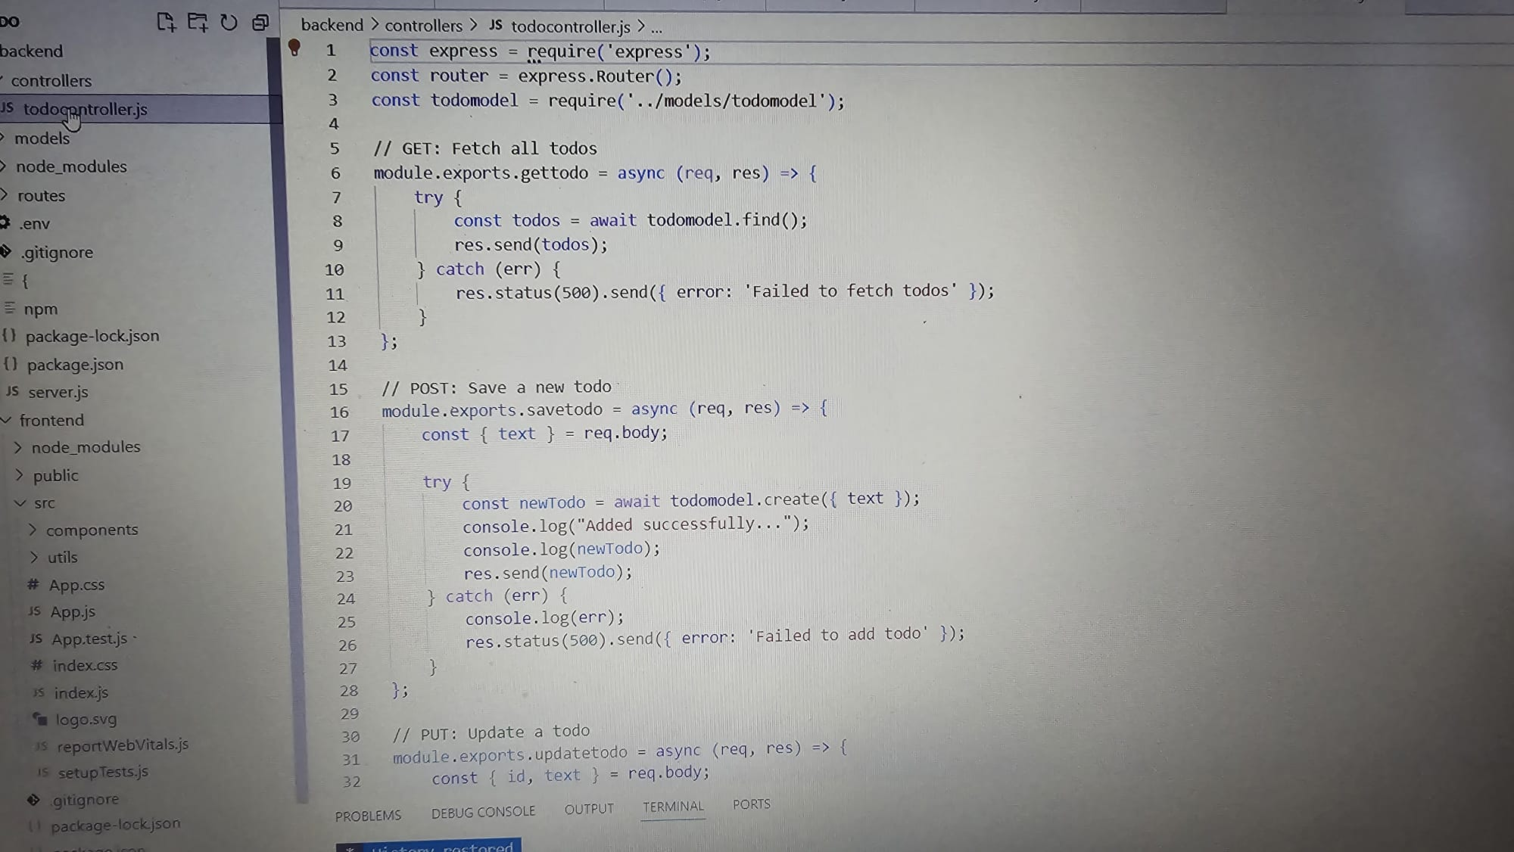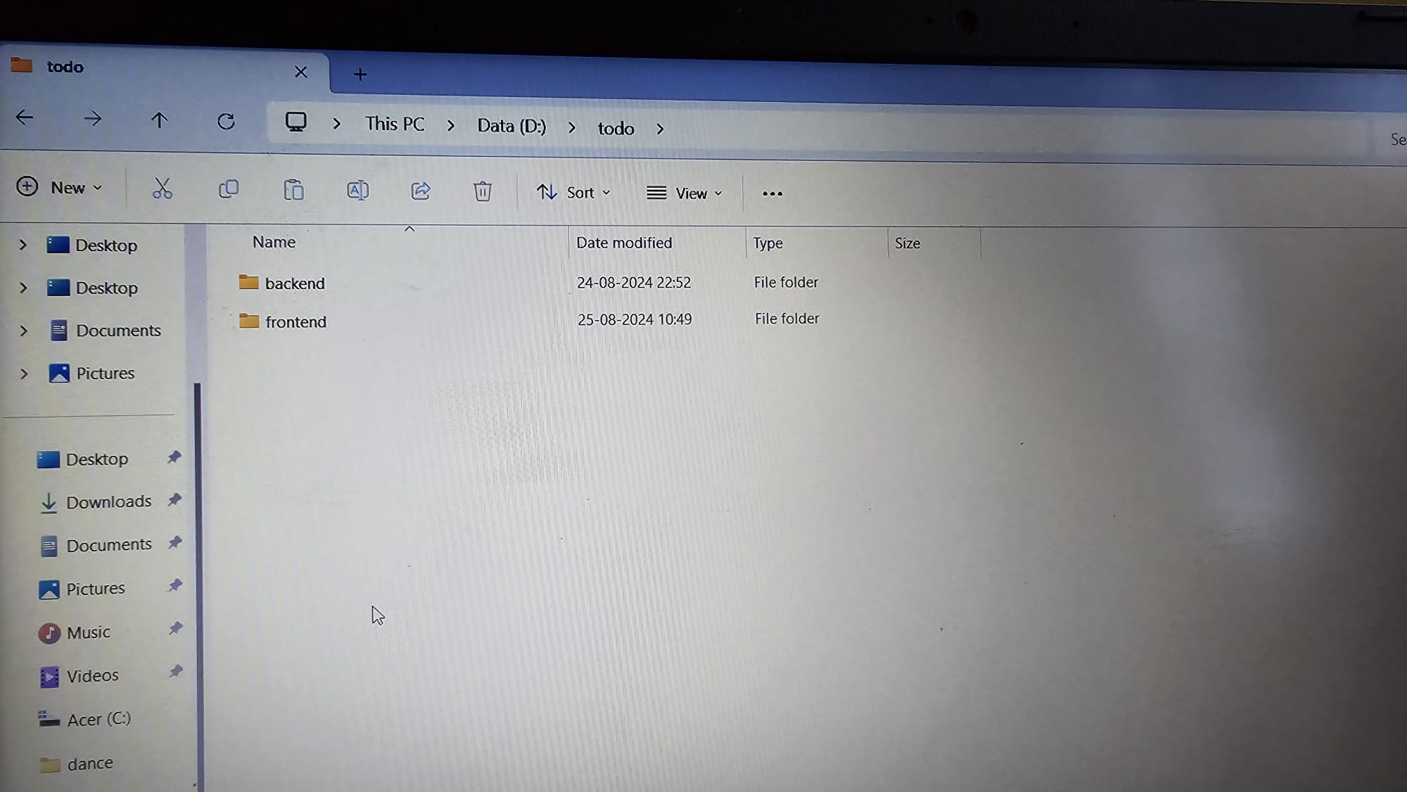

Date -30/7/2024

I learned about following topic, which help me to understand the topic and help me to know more about the information of this topic and it seems interesting to me to know more about this topic.

In this picture you can see my work of the following code which I have use in the project and I have learned about this in entire today and implement the code in it.

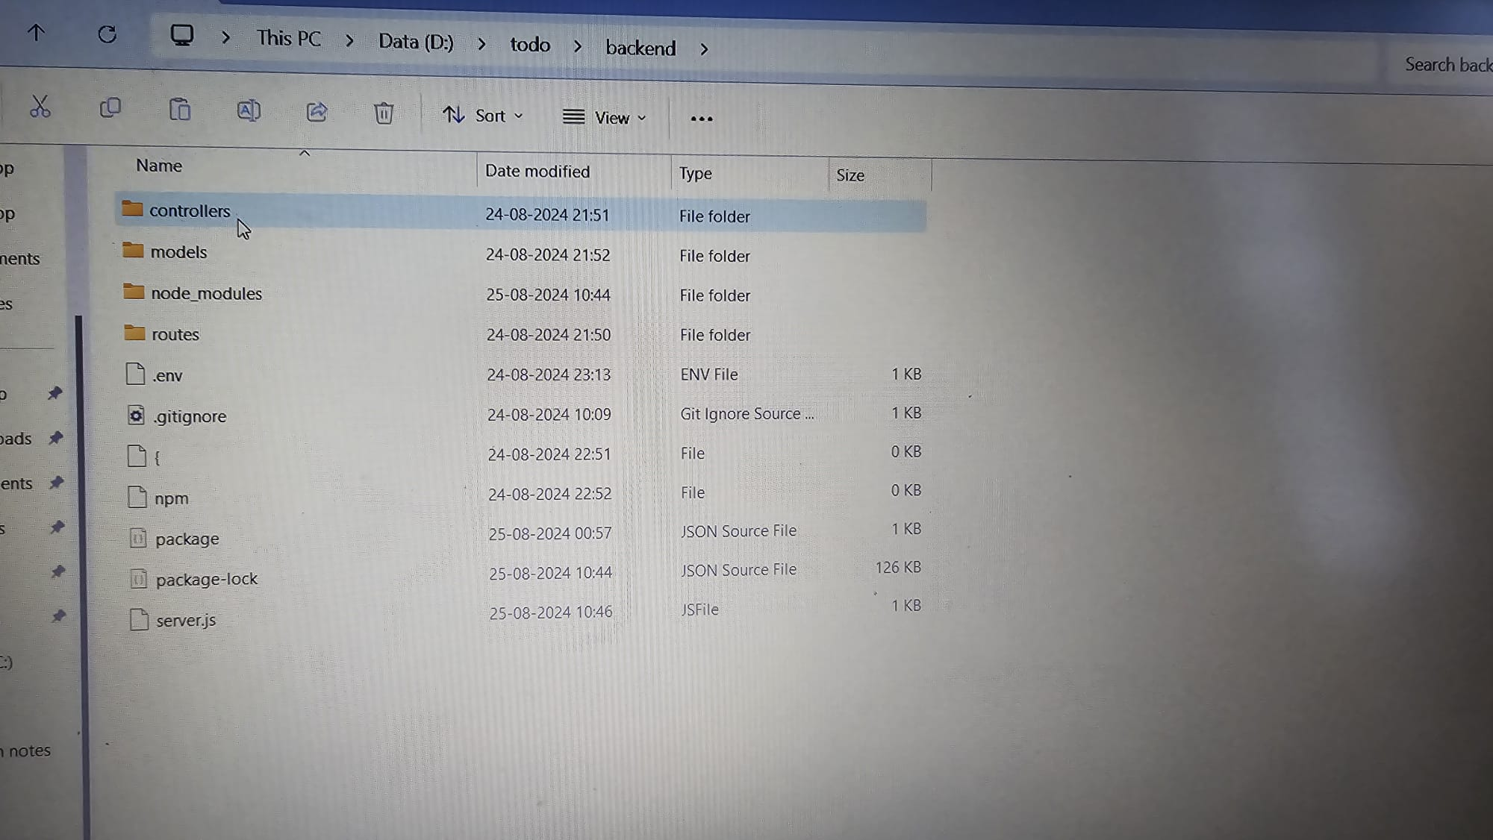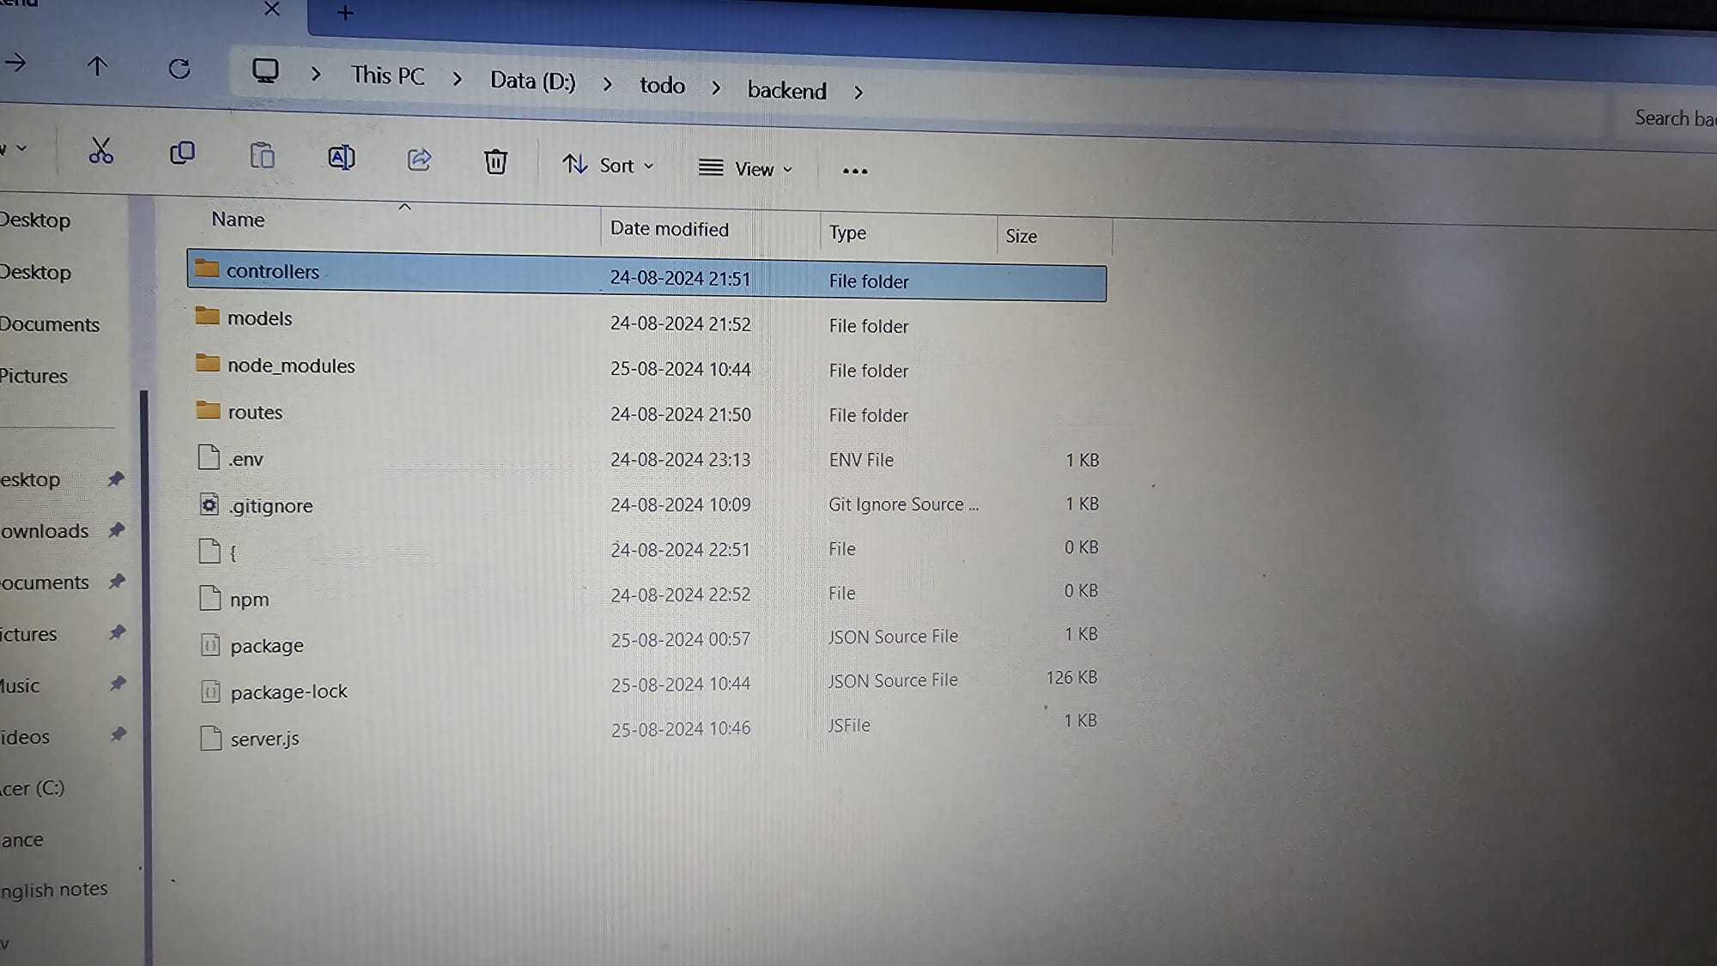

Date -1/8/2024

I learned about following topic, which help me to understand the topic and help me to know more about the information of this topic and it seems interesting to me to know more about this topic.

In this picture you can see my work of the following code which I have use in the project and I have learned about this in entire today and implement the code in it.

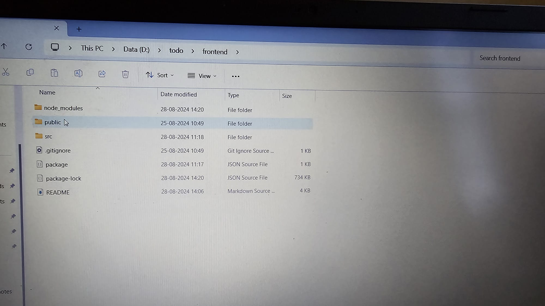

Date -2/8/2024

I learned about following topic, which help me to understand the topic and help me to know more about the information of this topic and it seems interesting to me to know more about this topic.

In this picture you can see my work of the following code which I have use in the project and I have learned about this in entire today and implement the code in it.

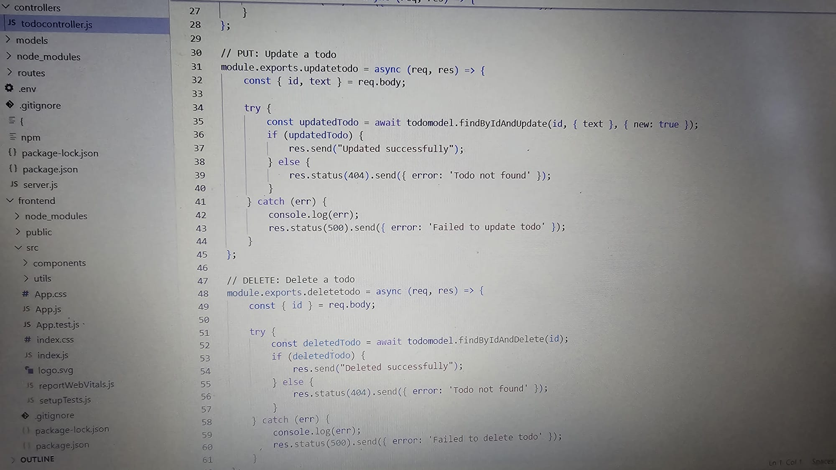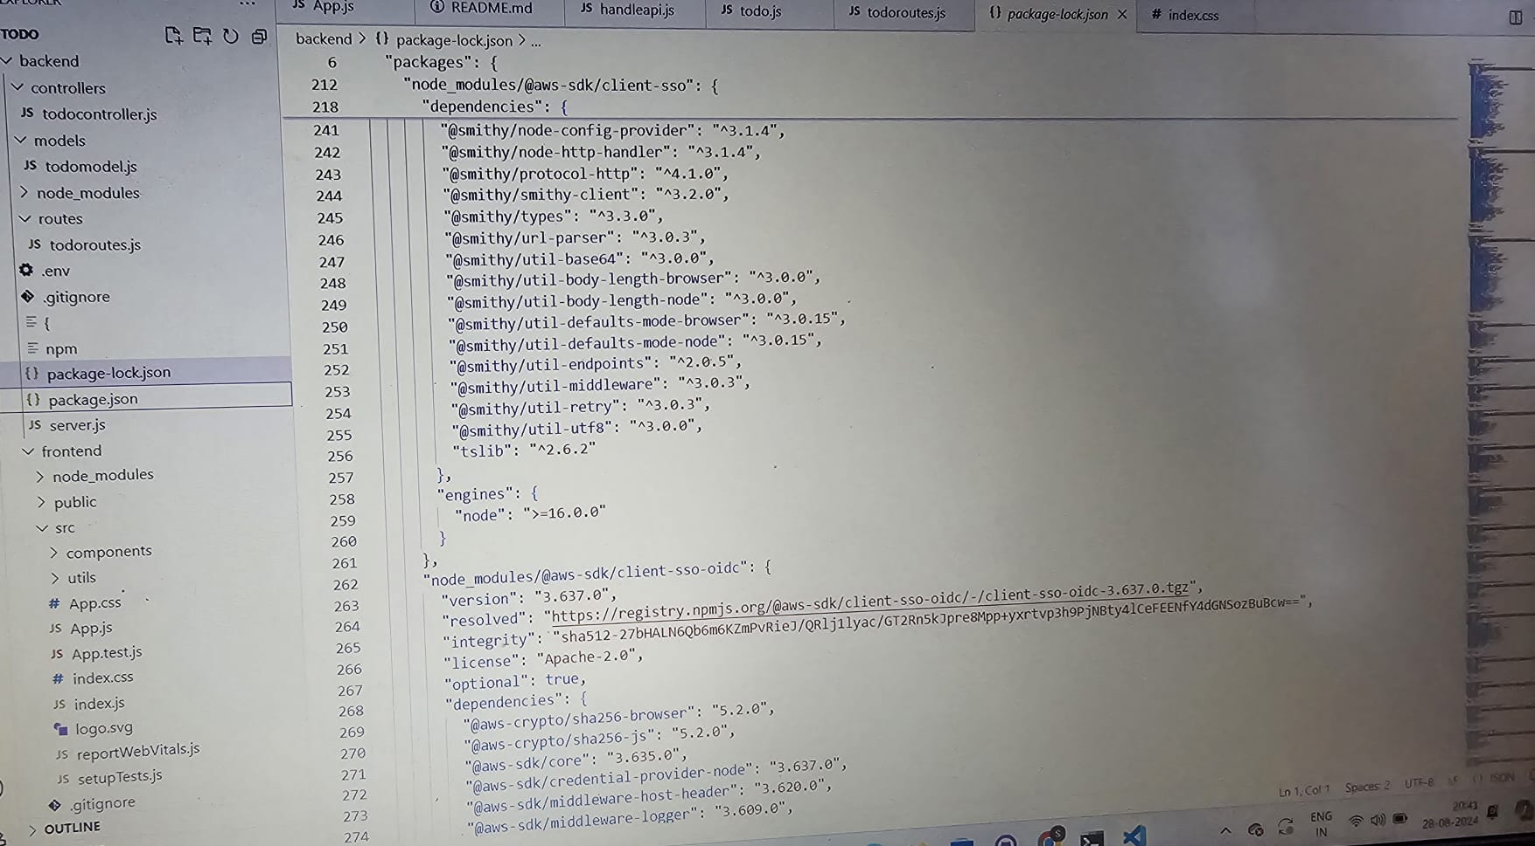

Date -3/8/2024

I learned about following topic, which help me to understand the topic and help me to know more about the information of this topic and it seems interesting to me to know more about this topic.

In this picture you can see my work of the following code which I have use in the project and I have learned about this in entire today and implement the code in it.

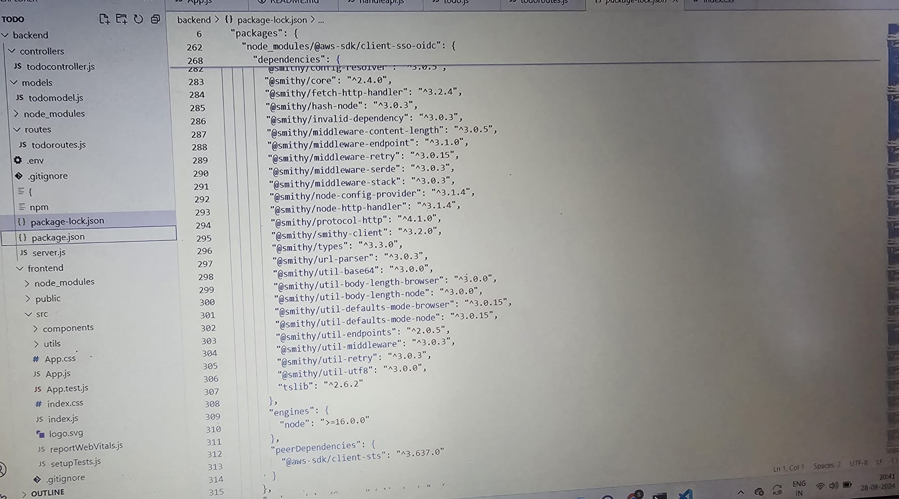

Date -5/8/2024

I learned about following topic, which help me to understand the topic and help me to know more about the information of this topic and it seems interesting to me to know more about this topic.

In this picture you can see my work of the following code which I have use in the project and I have learned about this in entire today and implement the code in it.

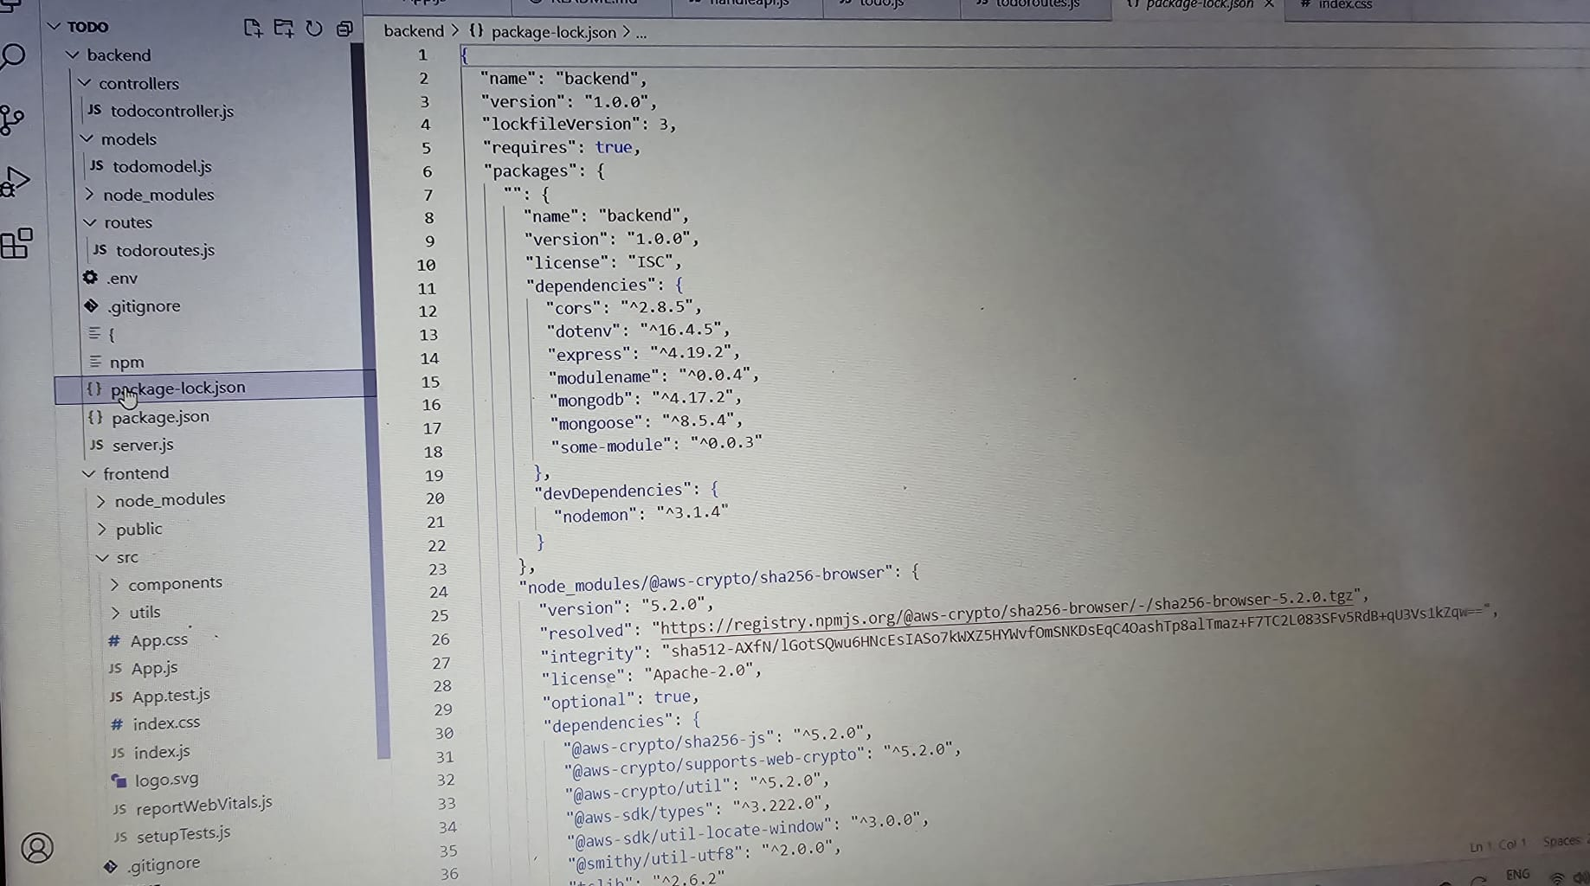



Date -6/8/2024

I learned about following topic, which help me to understand the topic and help me to know more about the information of this topic and it seems interesting to me to know more about this topic.

In this picture you can see my work of the following code which I have use in the project and I have learned about this in entire today and implement the code in it.

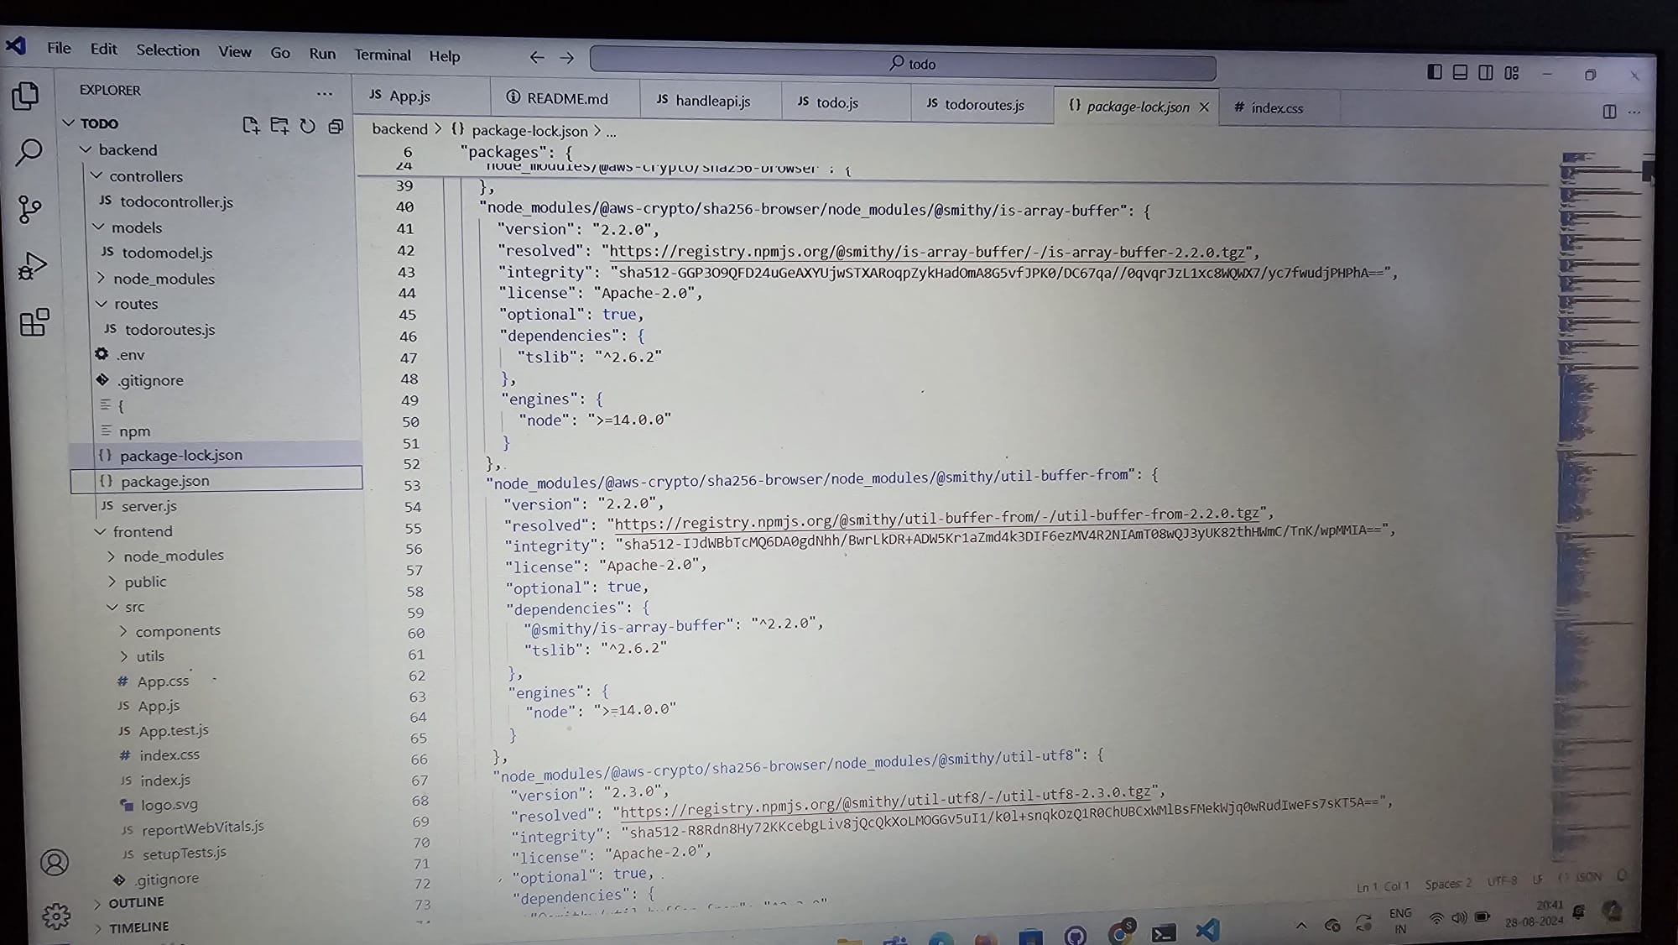

Date -8/8/2024

I learned about following topic, which help me to understand the topic and help me to know more about the information of this topic and it seems interesting to me to know more about this topic.

In this picture you can see my work of the following code which I have use in the project and I have learned about this in entire today and implement the code in it.

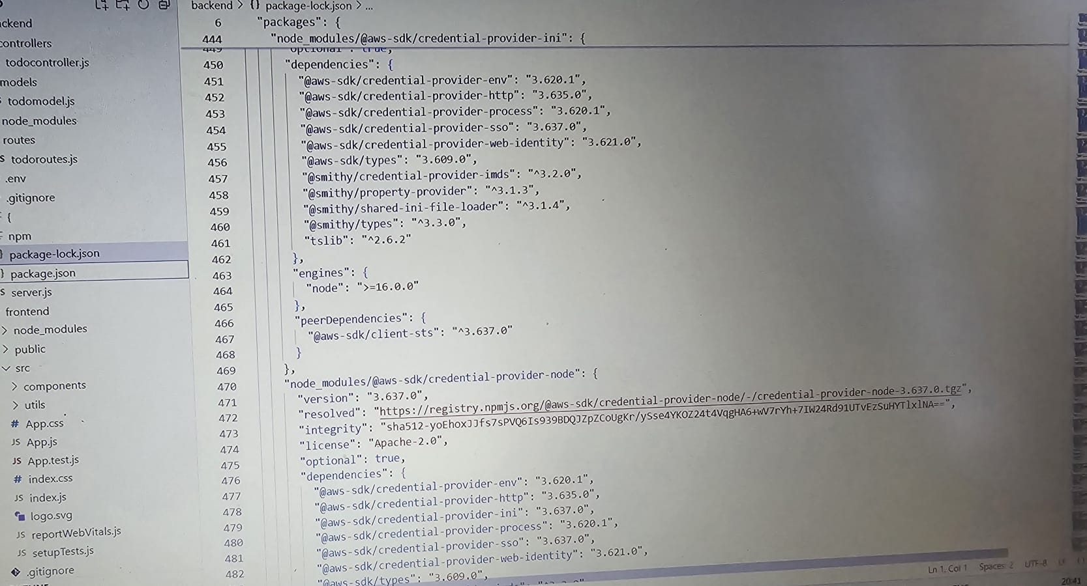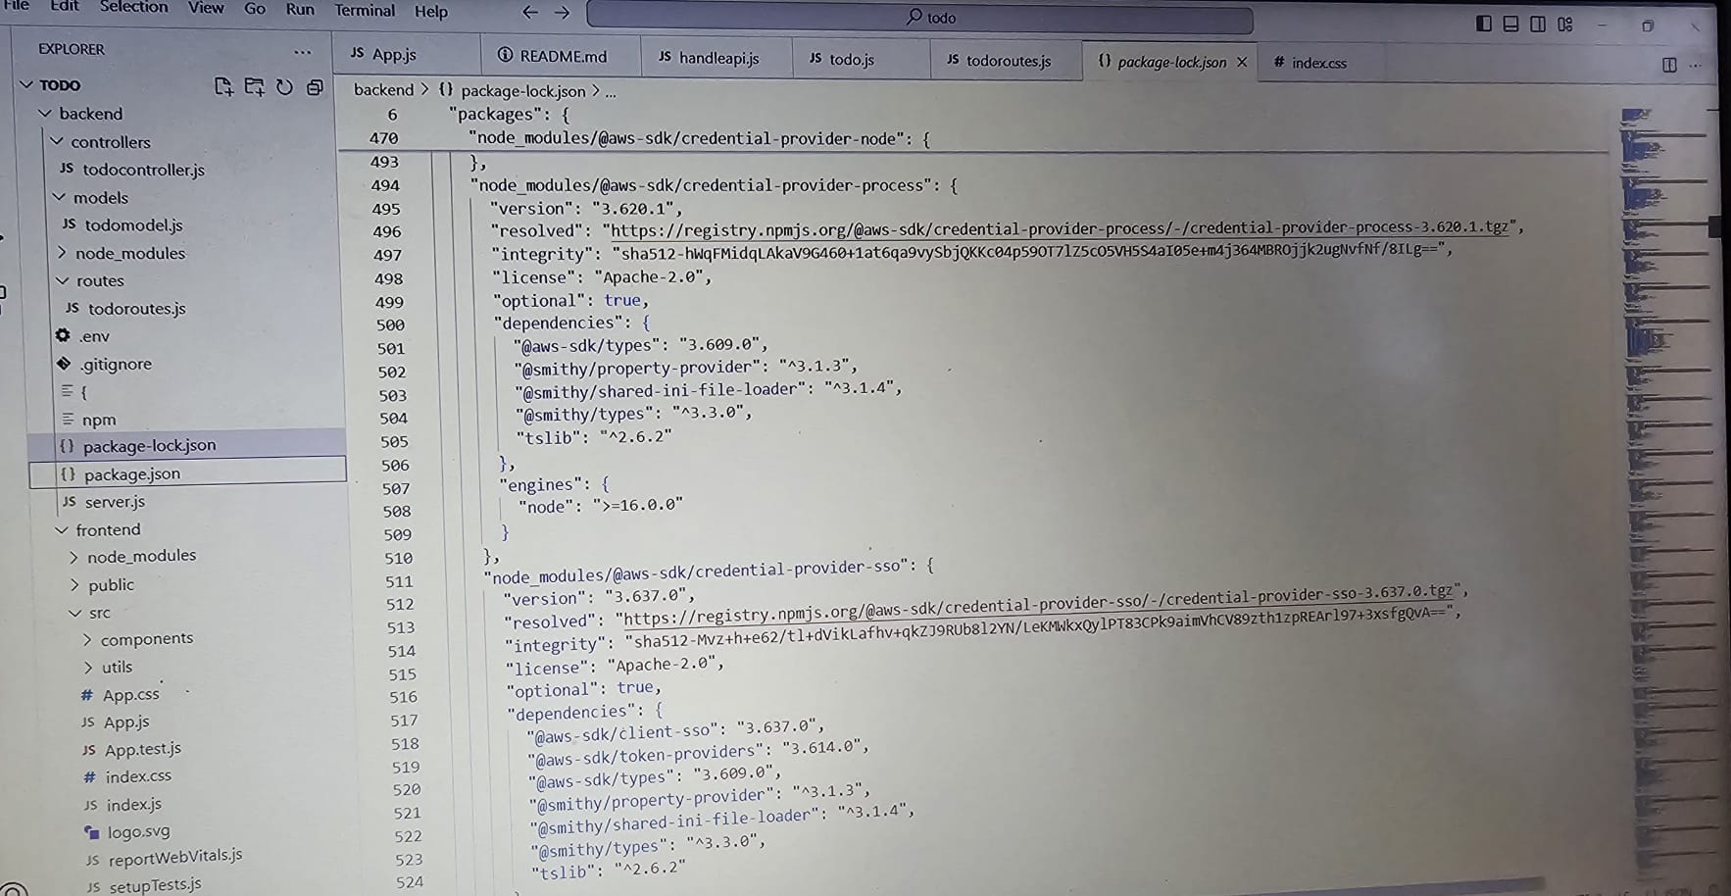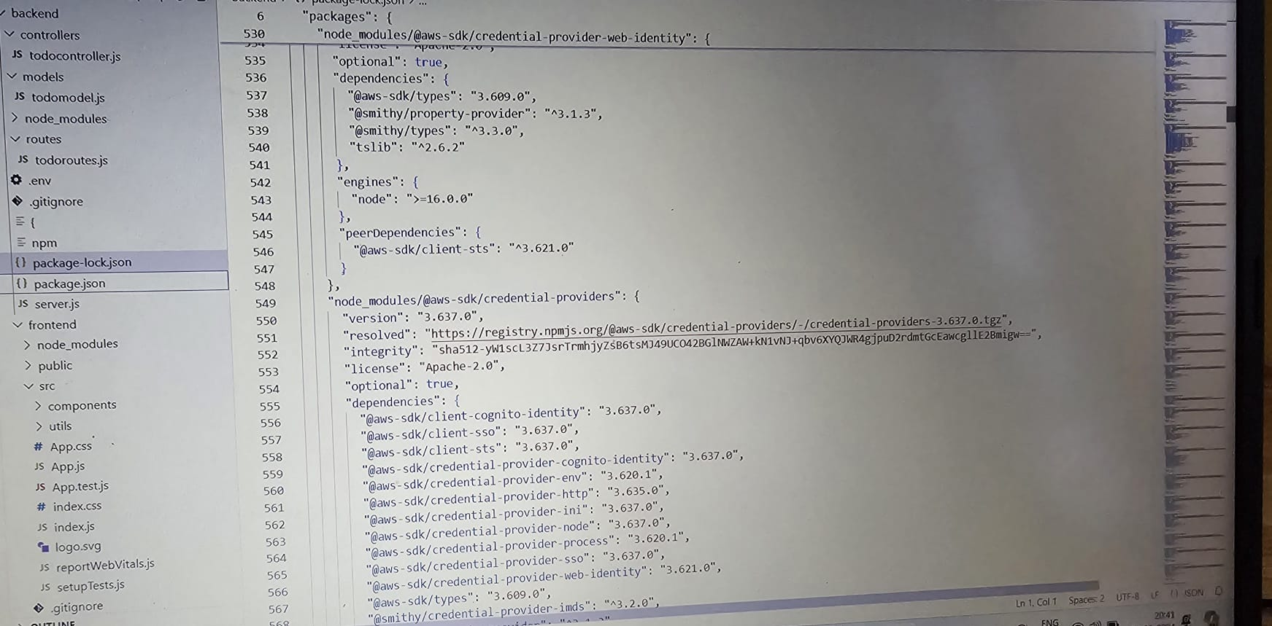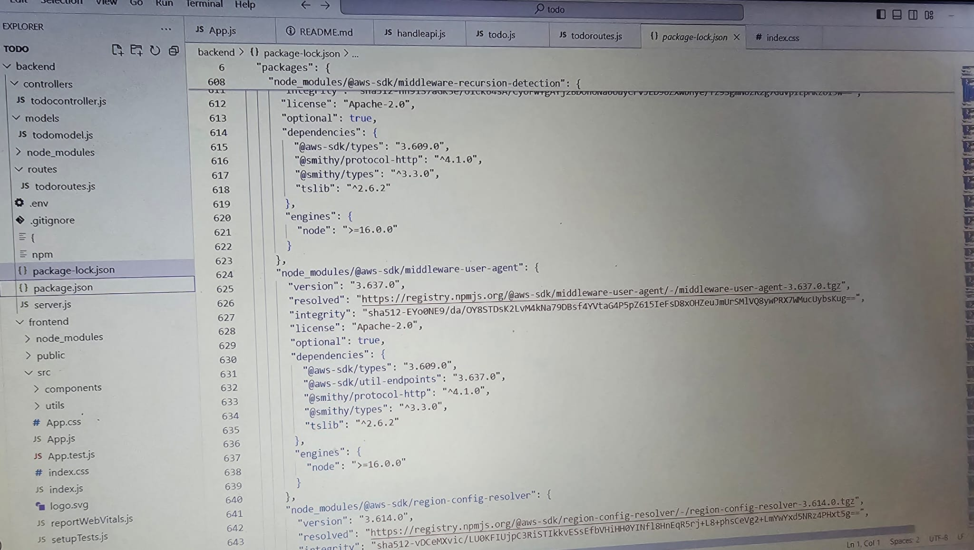 Date -10/8/2024

I learned about following topic, which help me to understand the topic and help me to know more about the information of this topic and it seems interesting to me to know more about this topic.

In this picture you can see my work of the following code which I have use in the project and I have learned about this in entire today and implement the code in it.

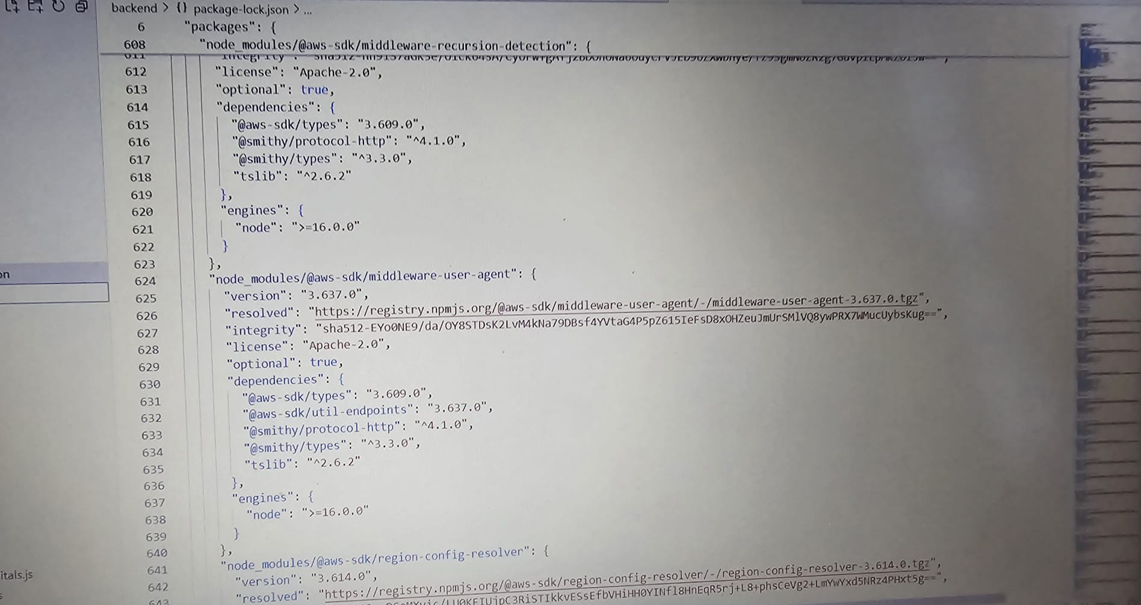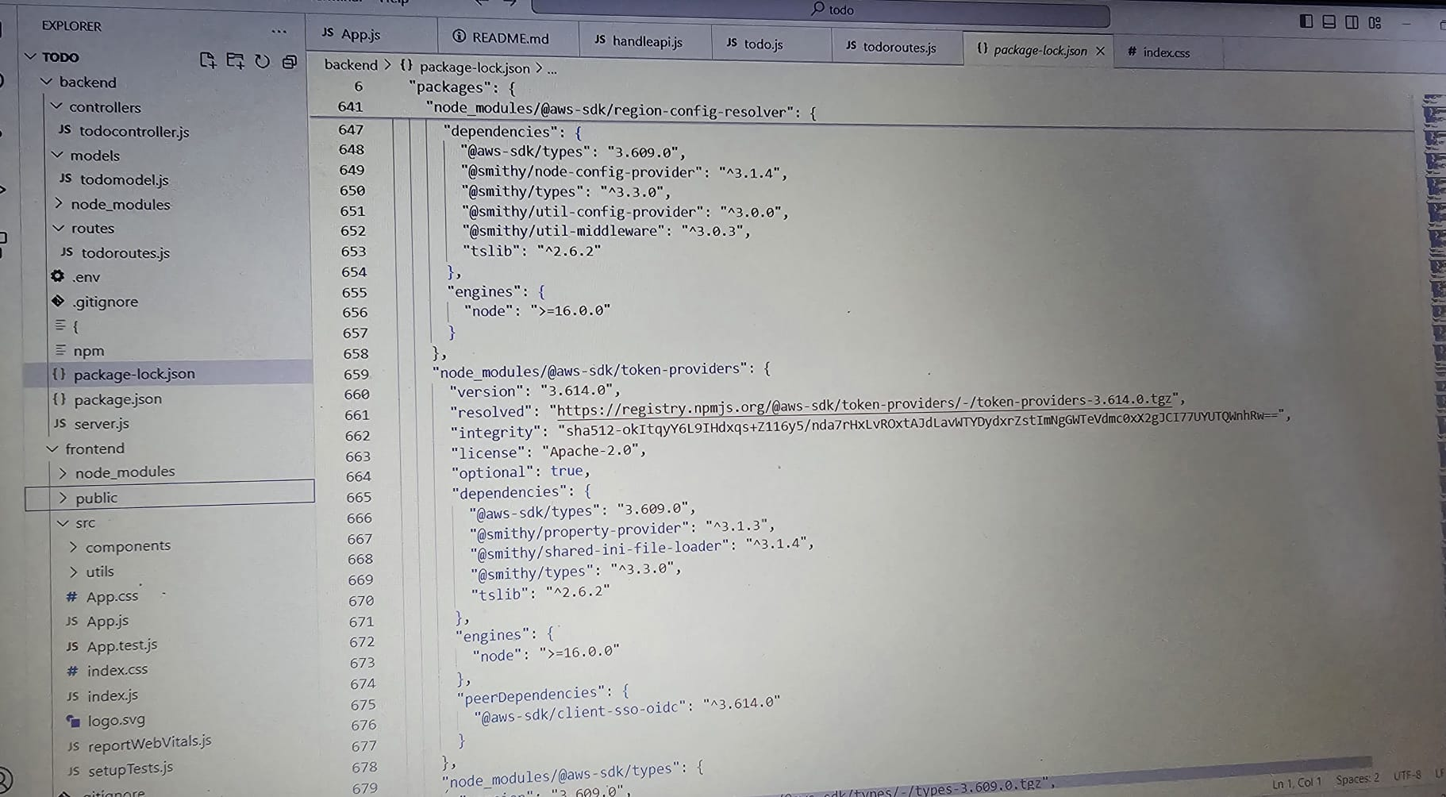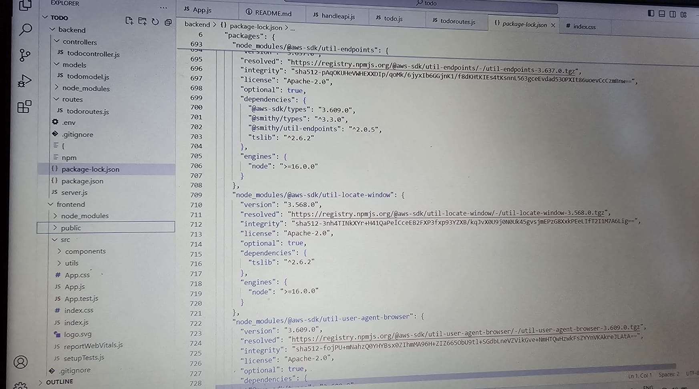



Date -13/8/2024

I learned about following topic, which help me to understand the topic and help me to know more about the information of this topic and it seems interesting to me to know more about this topic.

In this picture you can see my work of the following code which I have use in the project and I have learned about this in entire today and implement the code in it.

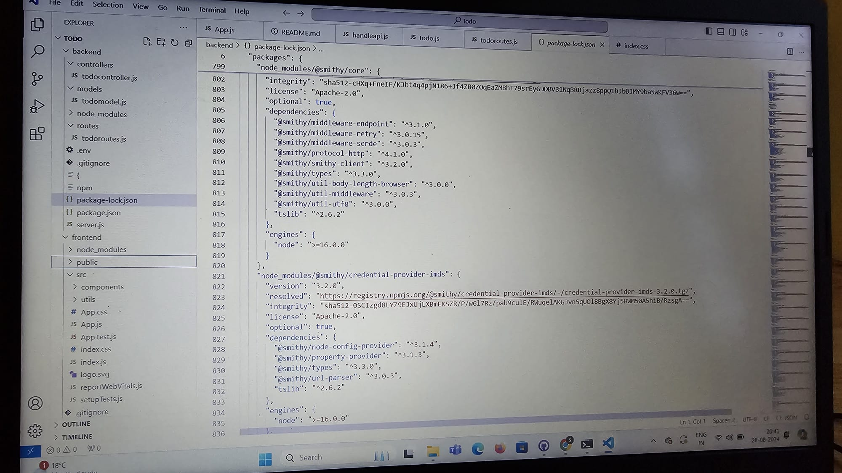

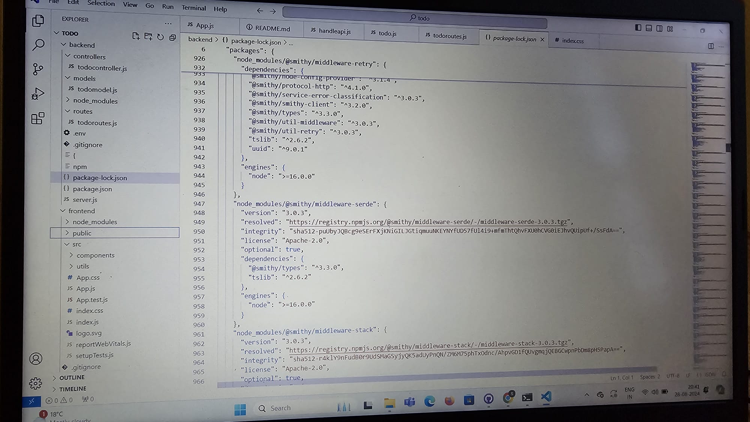 Date -16/8/2024

I learned about following topic, which help me to understand the topic and help me to know more about the information of this topic and it seems interesting to me to know more about this topic.

In this picture you can see my work of the following code which I have use in the project and I have learned about this in entire today and implement the code in it.

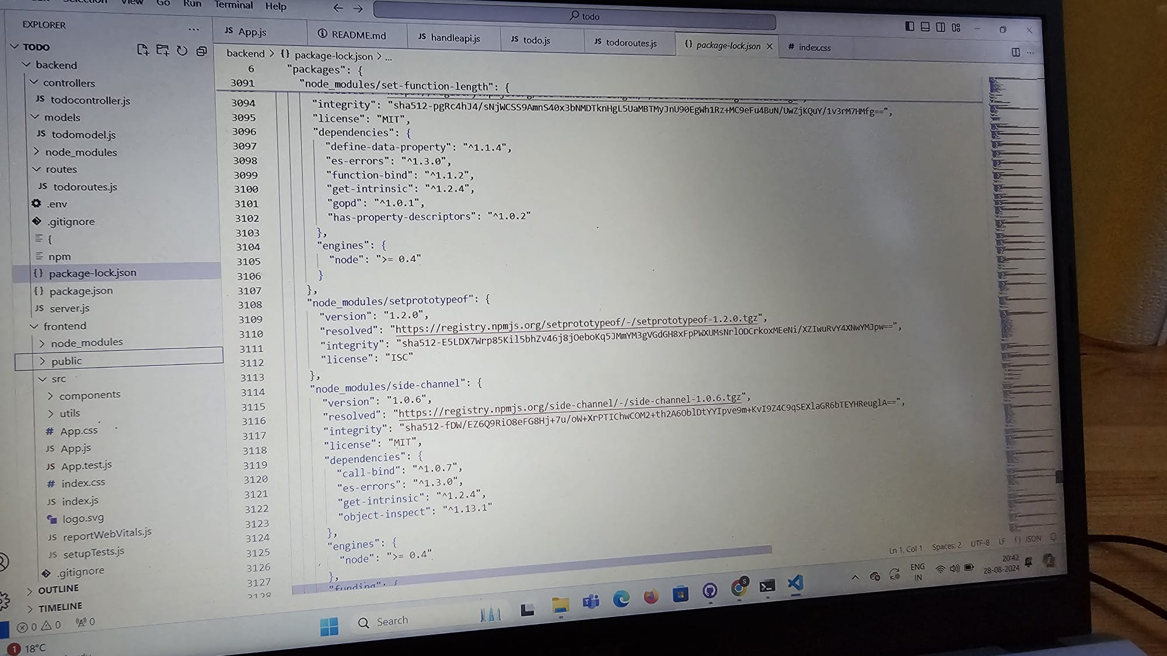

Date -20/8/2024

I learned about following topic, which help me to understand the topic and help me to know more about the information of this topic and it seems interesting to me to know more about this topic.

In this picture you can see my work of the following code which I have use in the project and I have learned about this in entire today and implement the code in it.

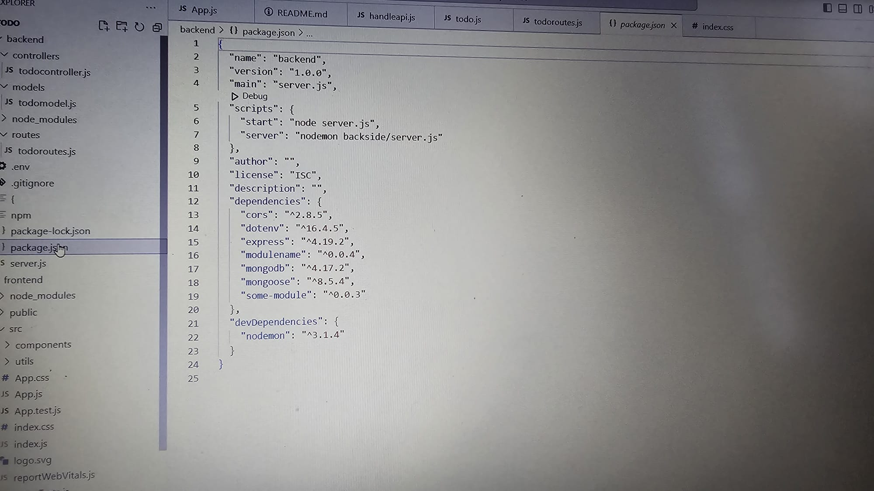

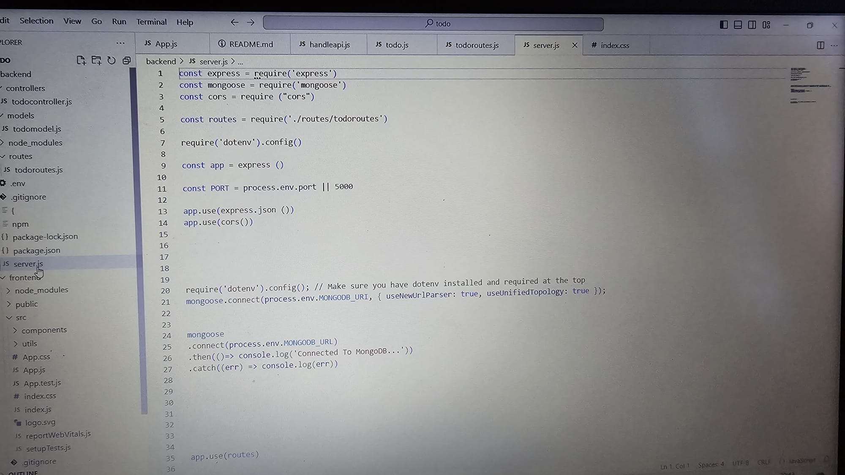

Date -21/8/2024

I learned about following topic, which help me to understand the topic and help me to know more about the information of this topic and it seems interesting to me to know more about this topic.

In this picture you can see my work of the following code which I have use in the project and I have learned about this in entire today and implement the code in it.

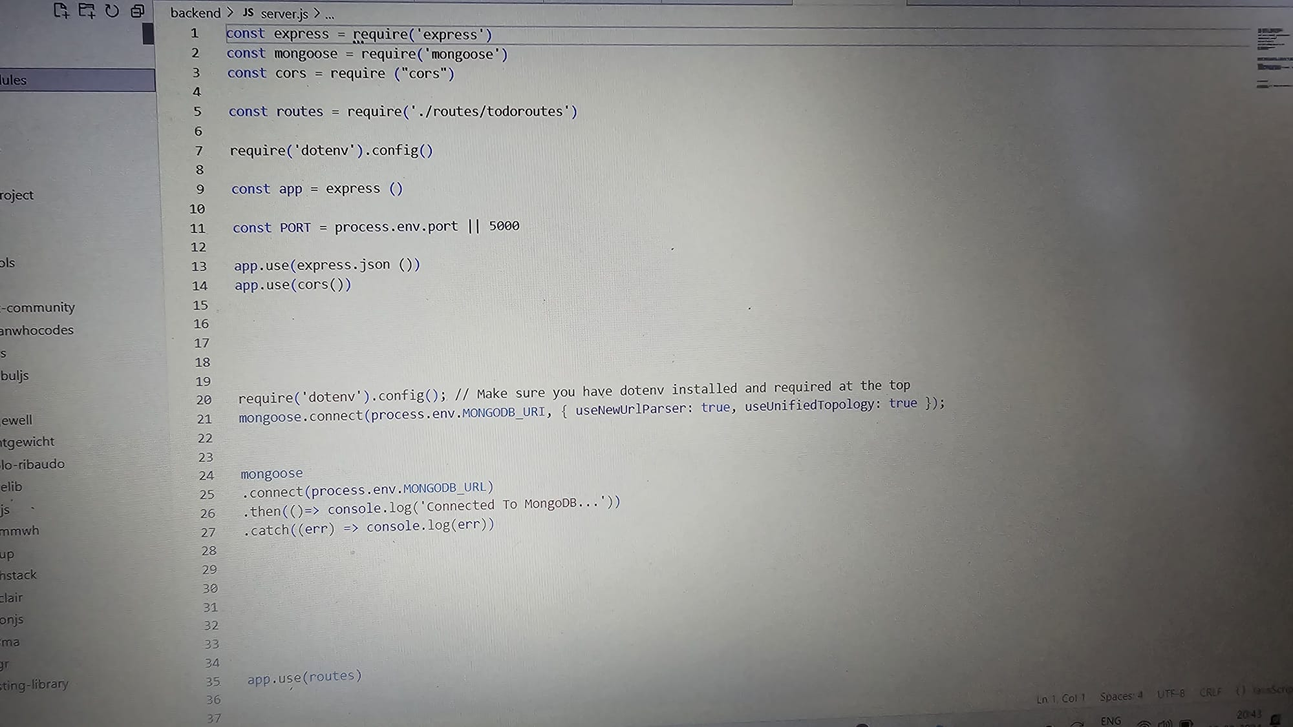

Date -22/8/2024

I learned about following topic, which help me to understand the topic and help me to know more about the information of this topic and it seems interesting to me to know more about this topic.

In this picture you can see my work of the following code which I have use in the project and I have learned about this in entire today and implement the code in it.

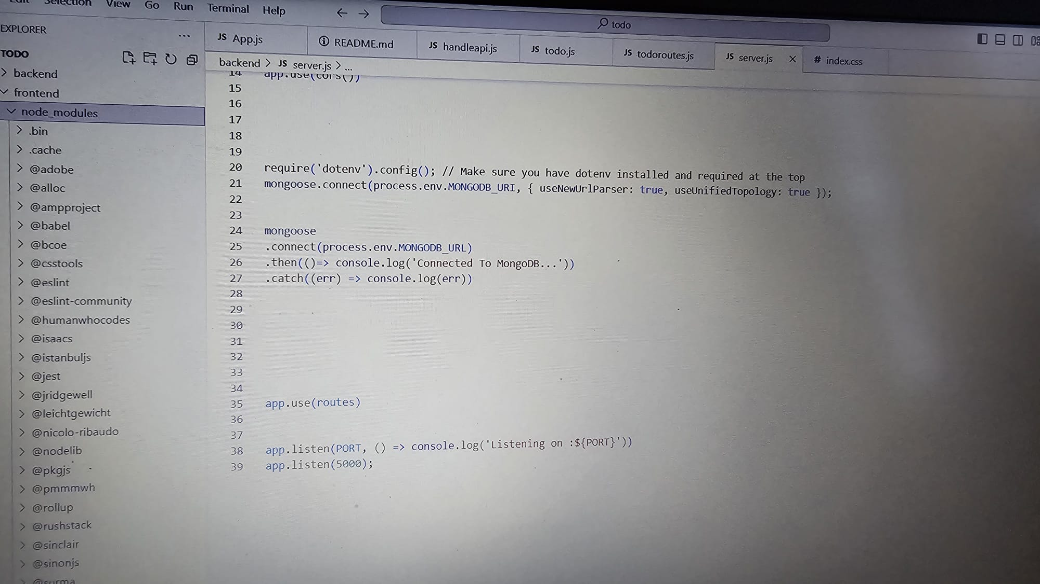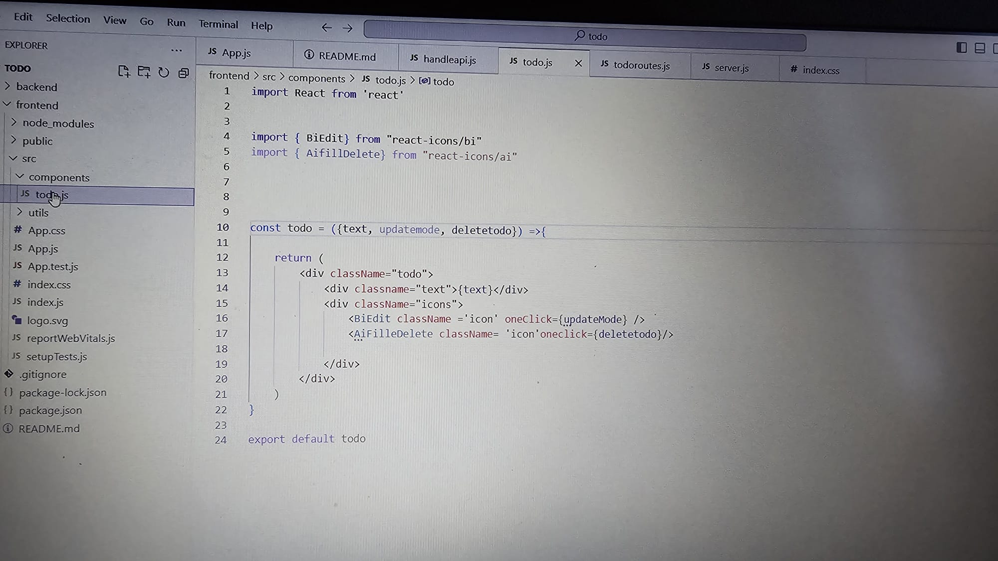 Date -24/8/2024

I learned about following topic, which help me to understand the topic and help me to know more about the information of this topic and it seems interesting to me to know more about this topic.

In this picture you can see my work of the following code which I have use in the project and I have learned about this in entire today and implement the code in it.

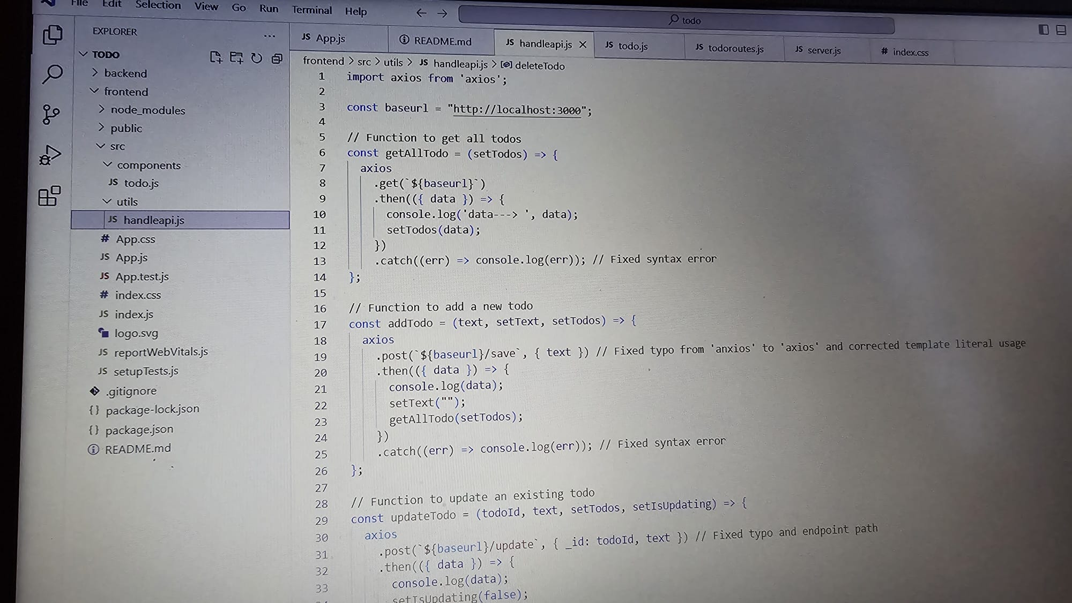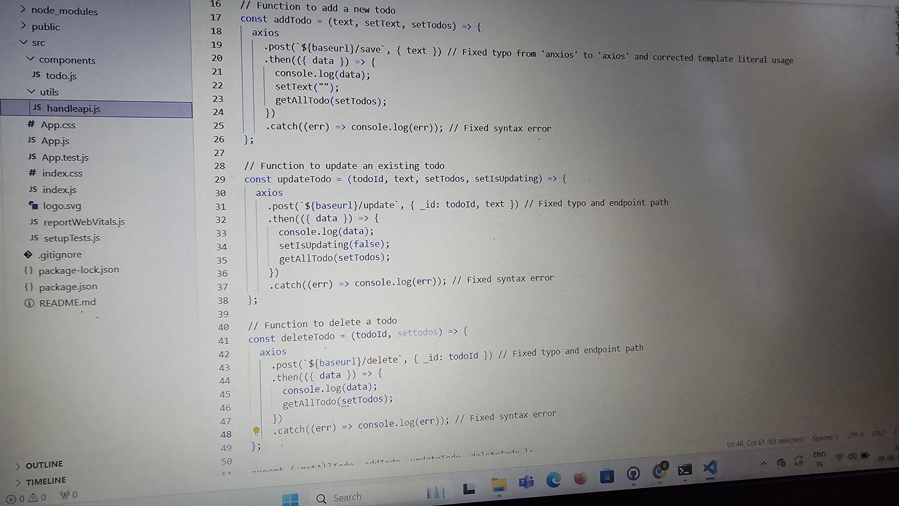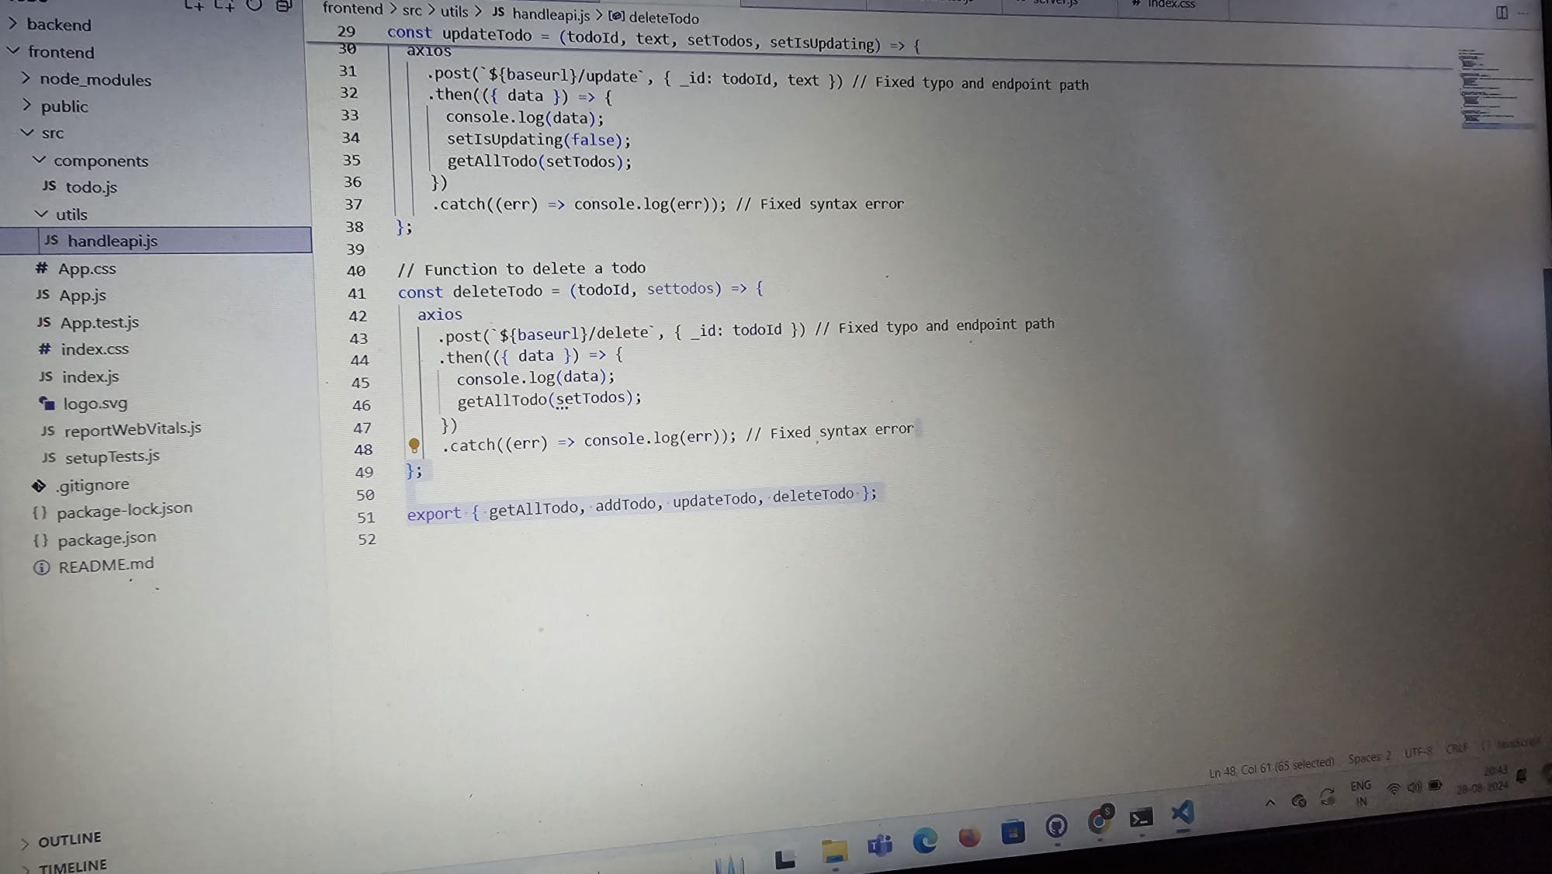 Date -26/8/2024

I learned about following topic, which help me to understand the topic and help me to know more about the information of this topic and it seems interesting to me to know more about this topic.

In this picture you can see my work of the following code which I have use in the project and I have learned about this in entire today and implement the code in it.

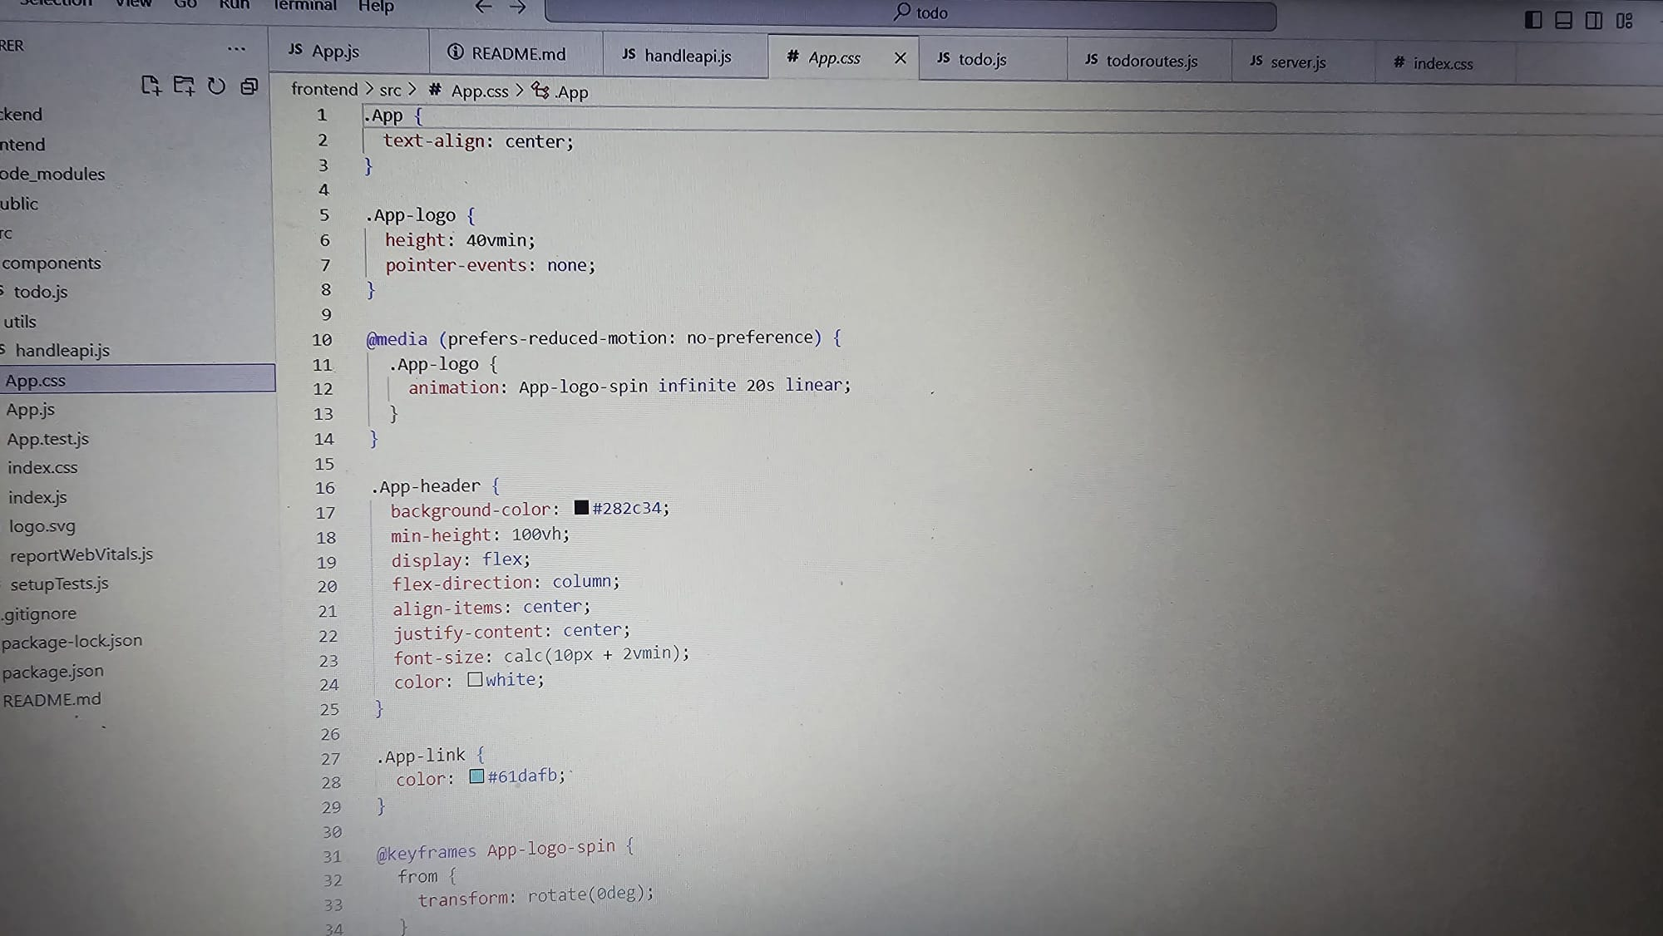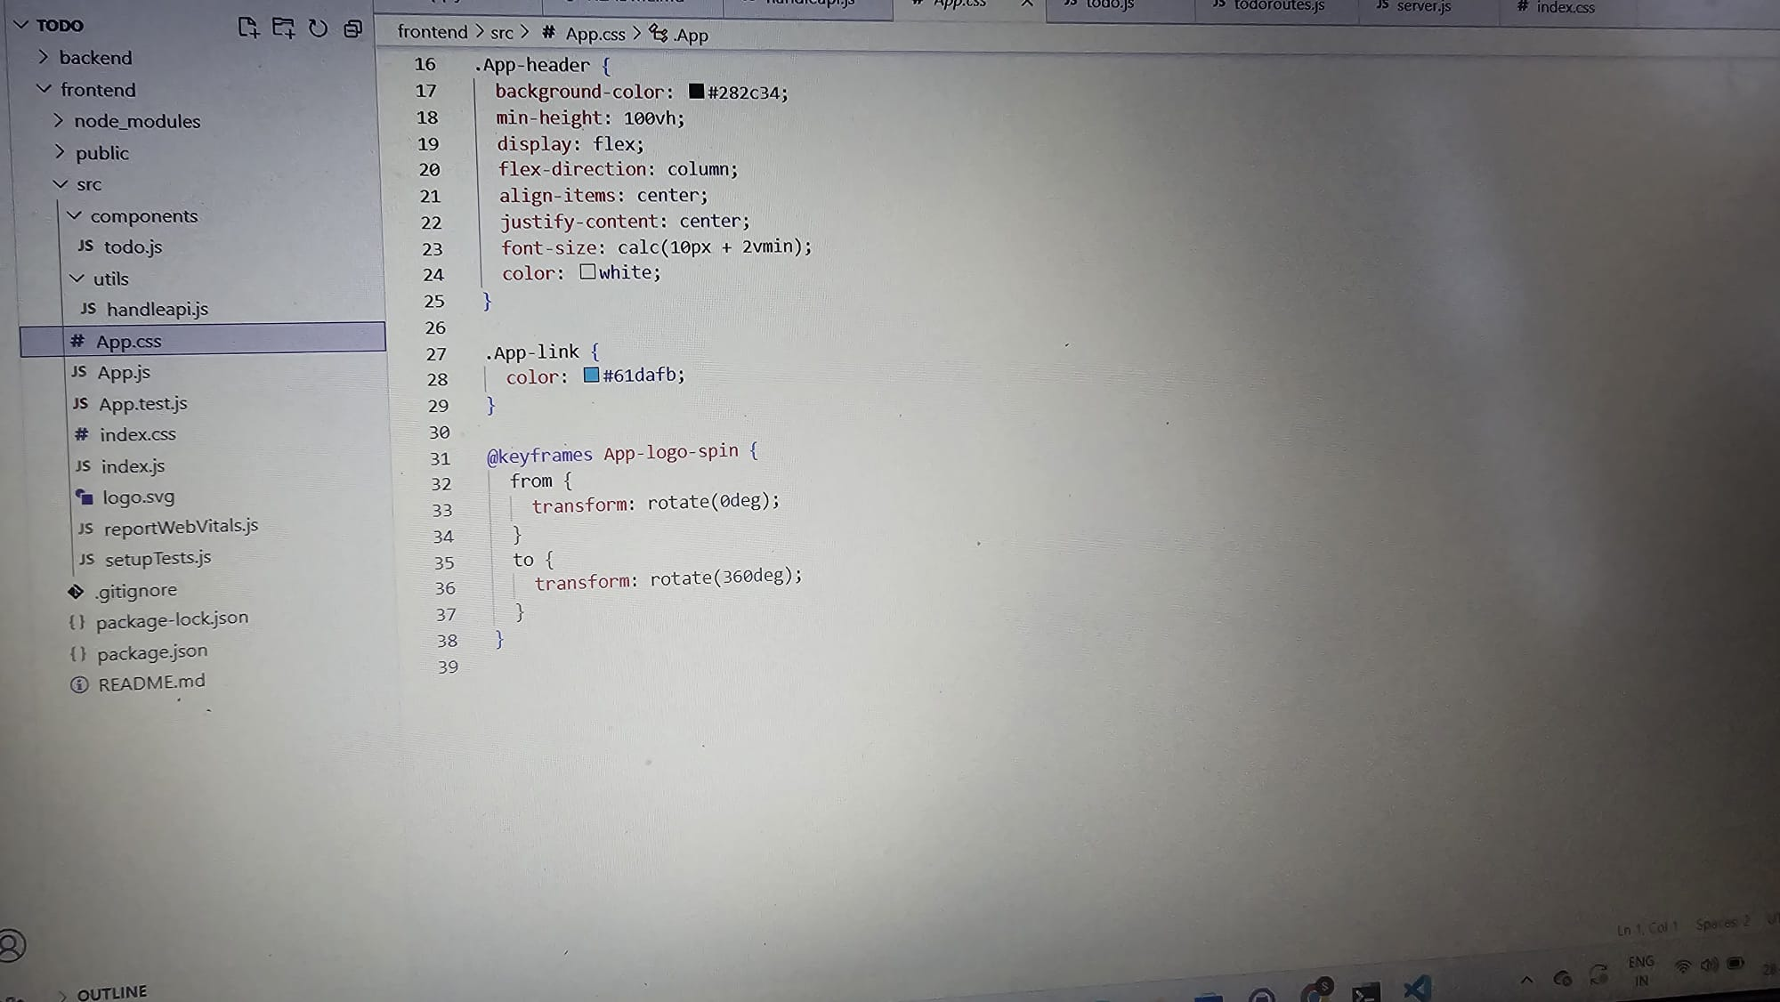 Date -27/8/2024

I learned about following topic, which help me to understand the topic and help me to know more about the information of this topic and it seems interesting to me to know more about this topic.

In this picture you can see my work of the following code which I have use in the project and I have learned about this in entire today and implement the code in it.

